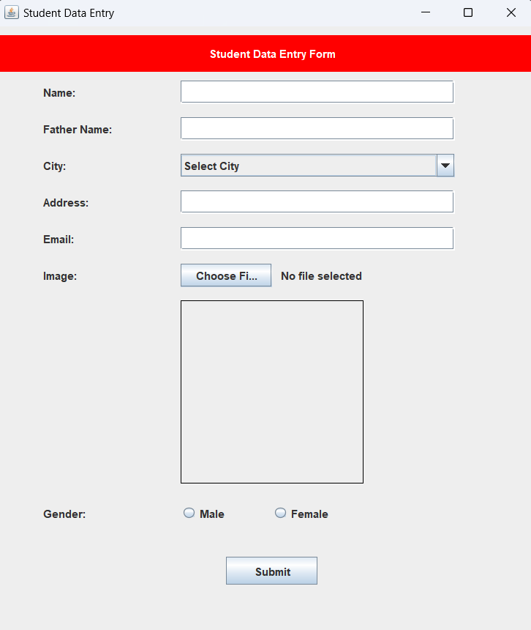

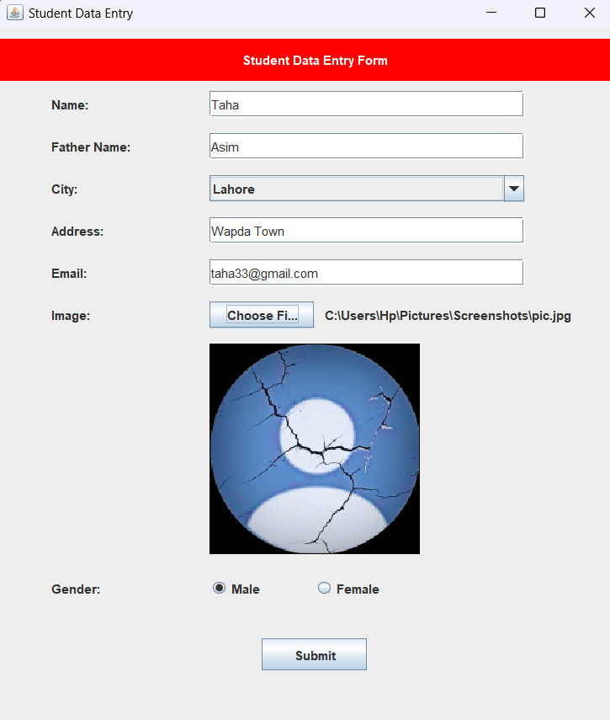

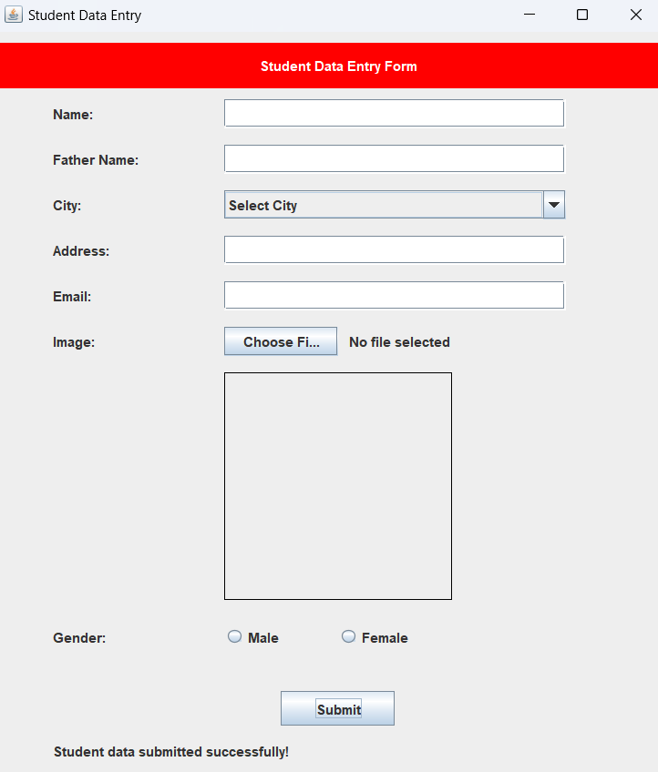

AFTER SUBMITTING ONE STUDENT DETAILS THE FORM WILL DISPLAY A MESSAGE “ STUDENT DATA SUBMITTED SUCCESSFULLY ” AND THEN RESETS THE FORM THEN USER CAN SUBMIT NEXT STUDENT’S INFORMATION.

HERE IS THE OUTPUT SCREEN WHICH SHOWS ALL THE STUDENTS' INFORMATION. IN THE IMAGE ABOVE, IT SHOWS THE DATA OF TWO STUDENTS.



CODE:

